**Elastic Bean Stalk**

**\*From free tier Account**

1. **Select Elastic Bean Stalk**

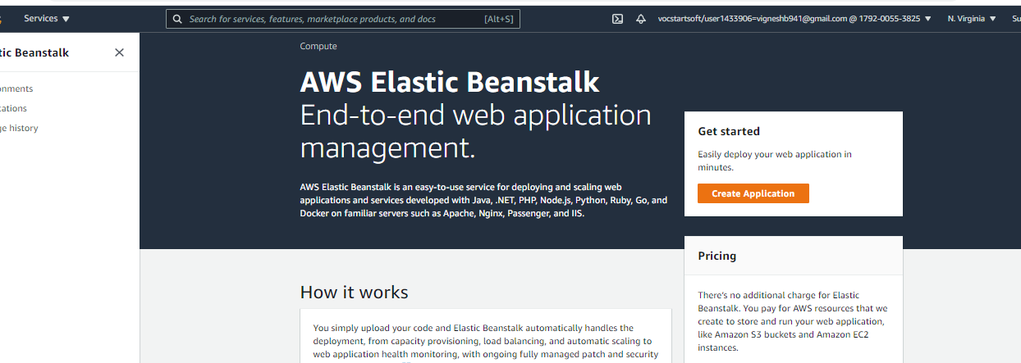

1. **Create EBS**

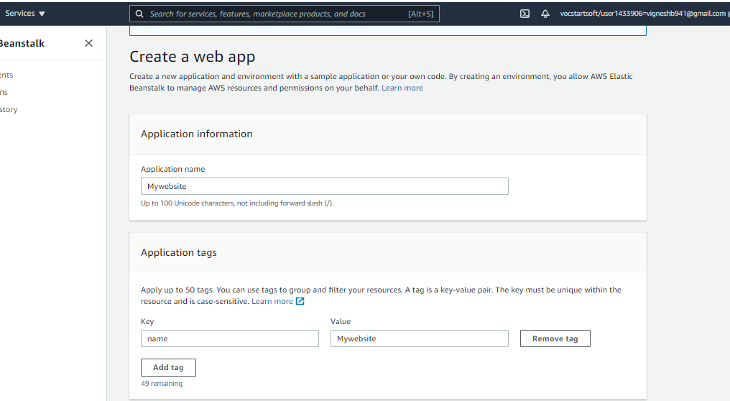

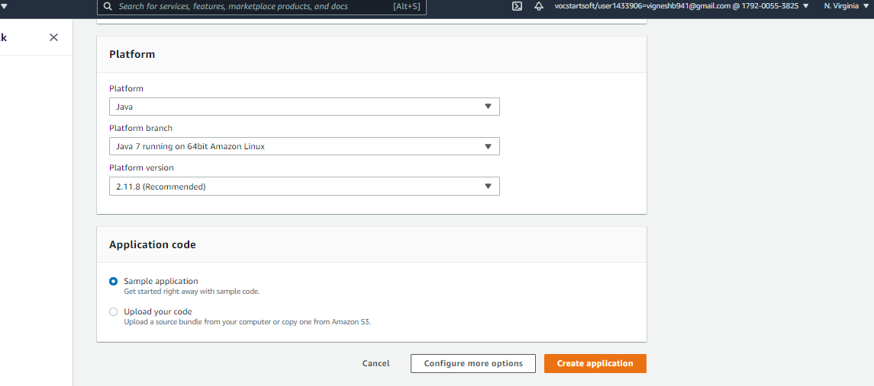

1. **Creating Environment**

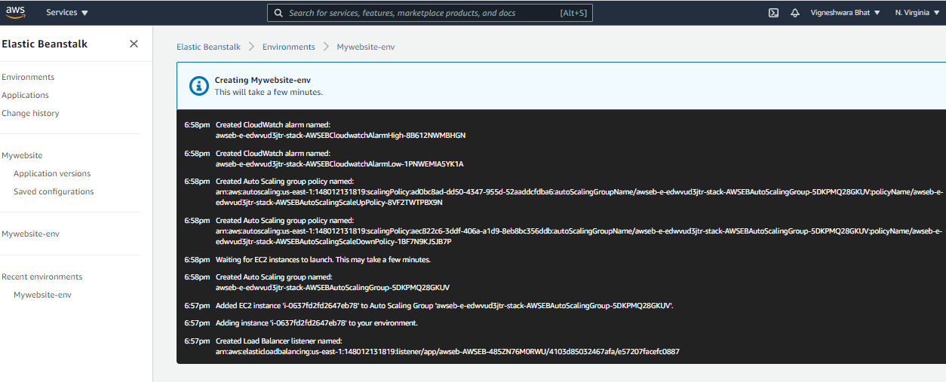

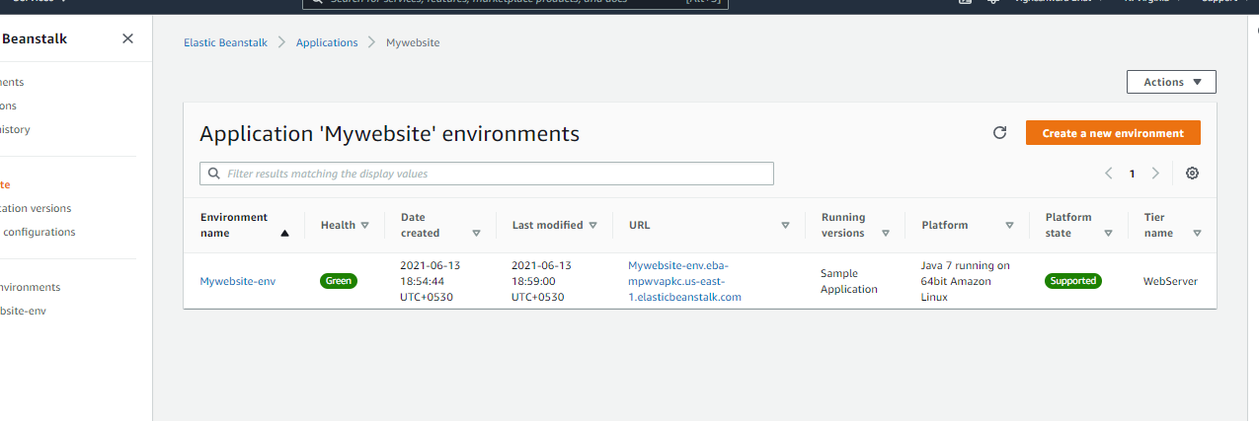

1. **EC2 instance created** 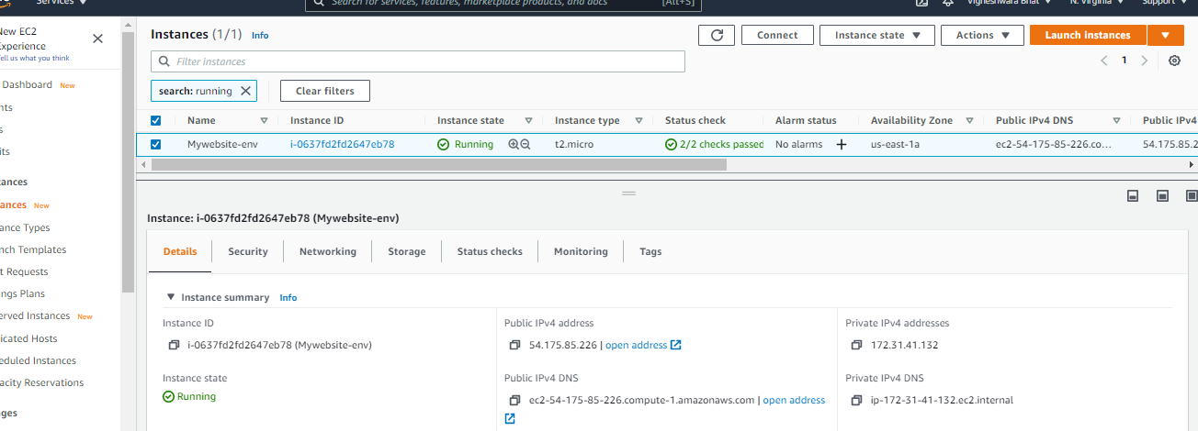
2. **AutoScaling instance created**

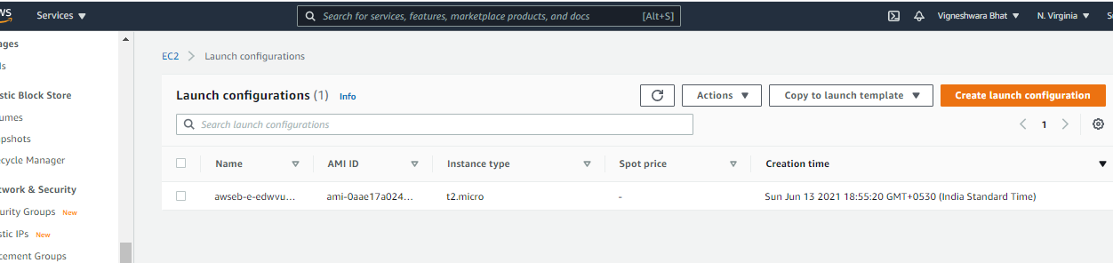

1. **Loadbalancer instance created**

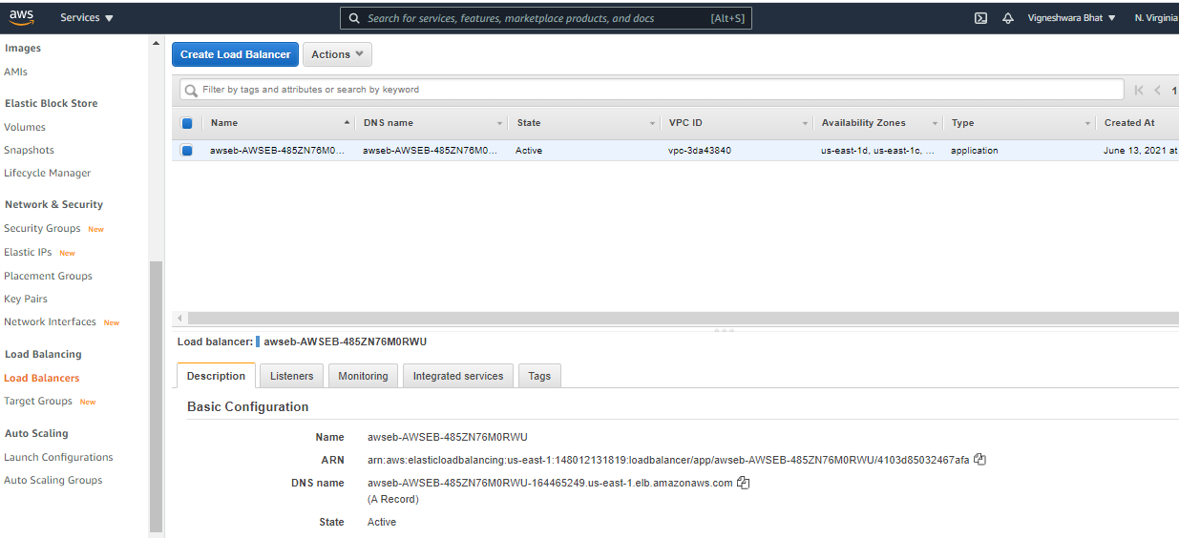

1. **Targetgroup created** 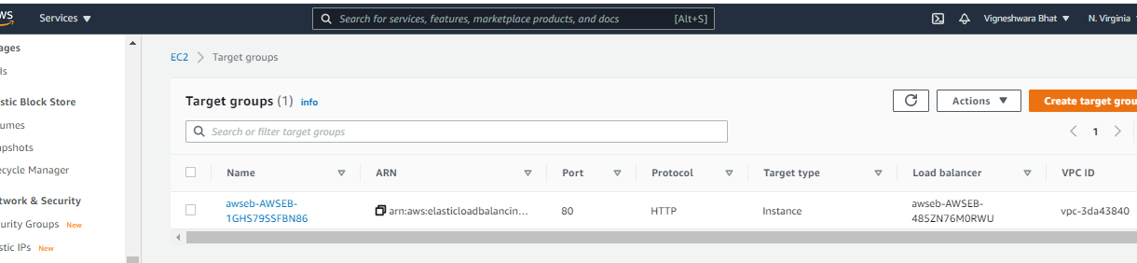
2. **Heath of the Deployed app in ElasticBeanStalk** 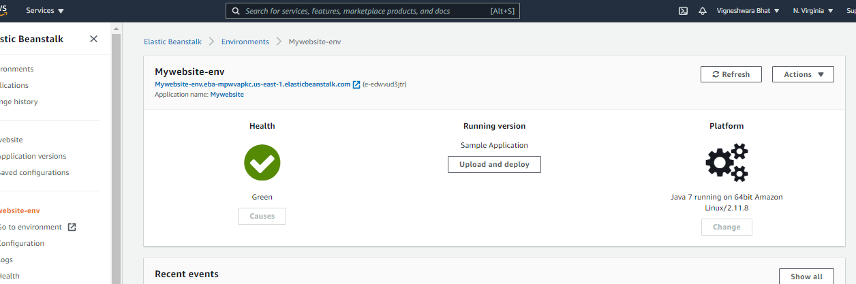
3. **Website using ElasticBeanStalk**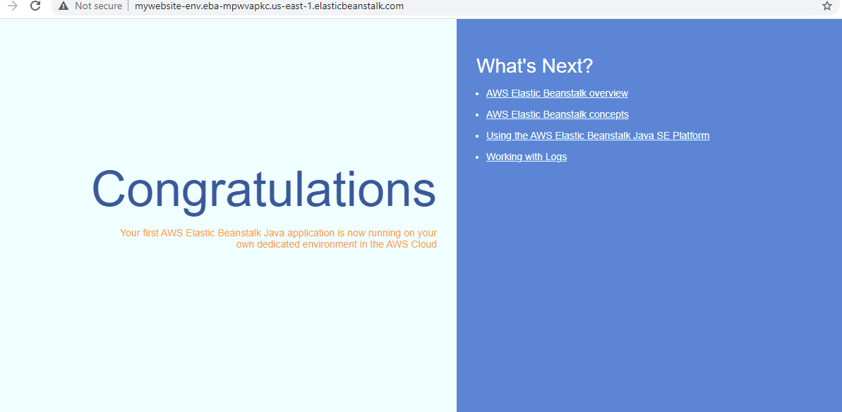
4. **Changing Capacity in Autoscaling**

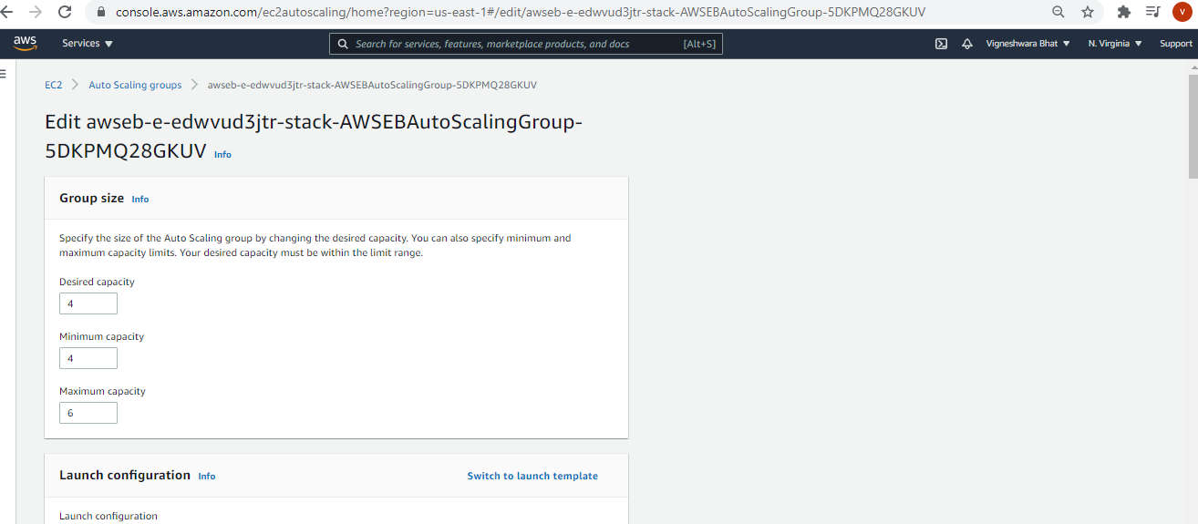 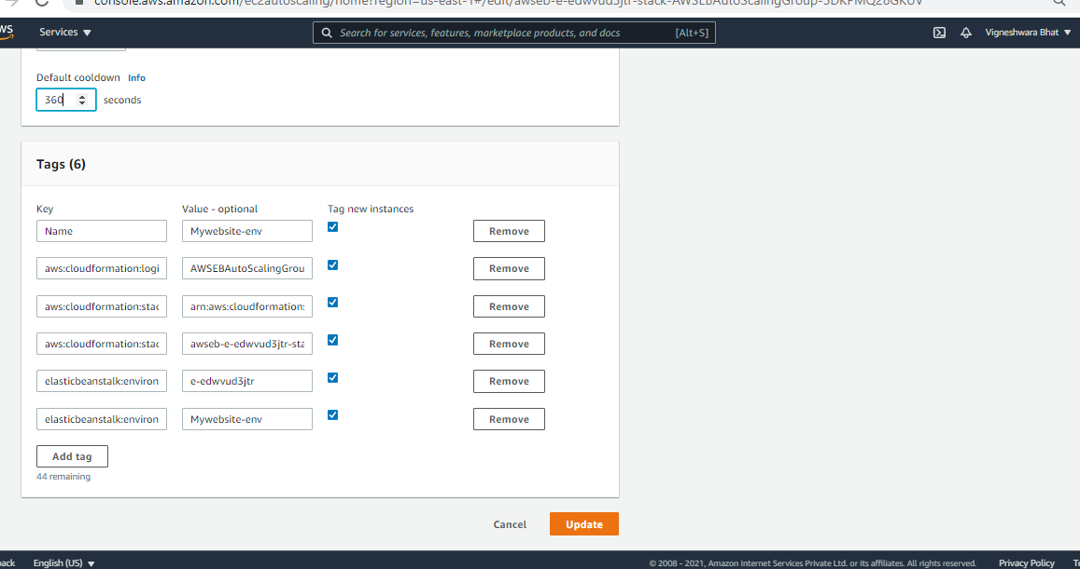

1. **Instances created** 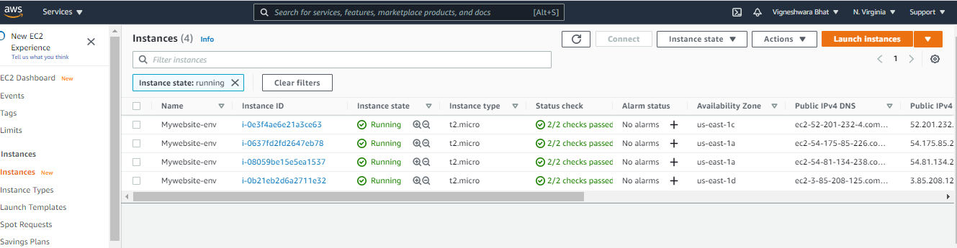
2. **Website using ElasticBeanStalk**

